Thread List / Text Feed Page:
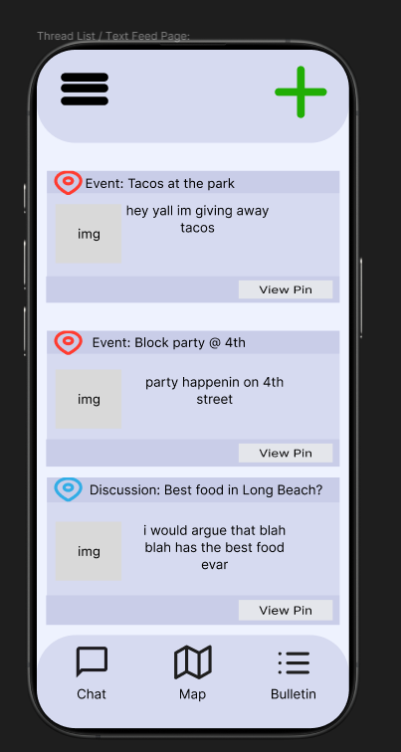
Thread detail page:
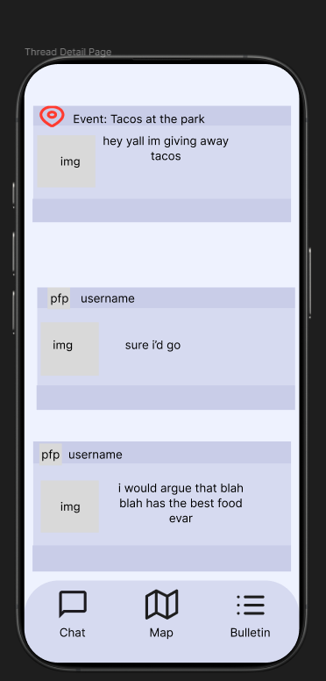
Color Palette
Darker Lavender: D6DAF0
Lighter Lavender: C9CDE8
Background: E4E6EB

Simple and clean color palette. If not these colors, something easy on the eyes.

https://www.figma.com/design/mgZ7ukoGCk8ZvrJXFMXLqv/Max-s-Thread---List-Submission?node-id=3-685&t=i0II2WGww1I7pO51-1

https://coolors.co/668586-82aeb1-93c6d6-a7acd9-9e8fb2

these could work too^

